# PROJECT REPORT

Team 7

ROLL No: 21BCS061, 21BCS008, 21BCS047, 21BCS041, 21BCS039

Project Idea:

The idea of the project is to automate and digitalize the data storing process of a rental company named Dream Home private limited. Our idea is to create a database with the relational aspect well maintained to make the transactions effectively. And improving data accuracy, efficiency and better customer service

Implementation Procedure:

Designing the Database Schema: We have started by designing a database schema for Dream Home’s properties. This schema includes tables for property details, customer details which are divided into two types one looks for rent and the other rents his/her property, rental agreements, and lease details. We then used MySQL Workbench to design the schema. We have also designed Entity relationship diagram (E-R Diagram)

For better understanding of the schema.

Creating the Database: Once we have designed the schema, we will create the database in MySQL. We will create the tables, set up the relationships between them, and add sample data to test the database.

Developing the UI: We then developed a user interface (UI) to interact with the database. We used a programming language such as Python library tkinter to create the UI. The UI will allow users to perform tasks such as client registration, owner registration, registering a new property, updating property details, managing rental agreements, and viewing comments on a property.

Testing and Debugging: We have tested the database and the UI to ensure that they are working correctly. We identified and fixed any bugs or issues that we encountered during testing.

ER Diagram:

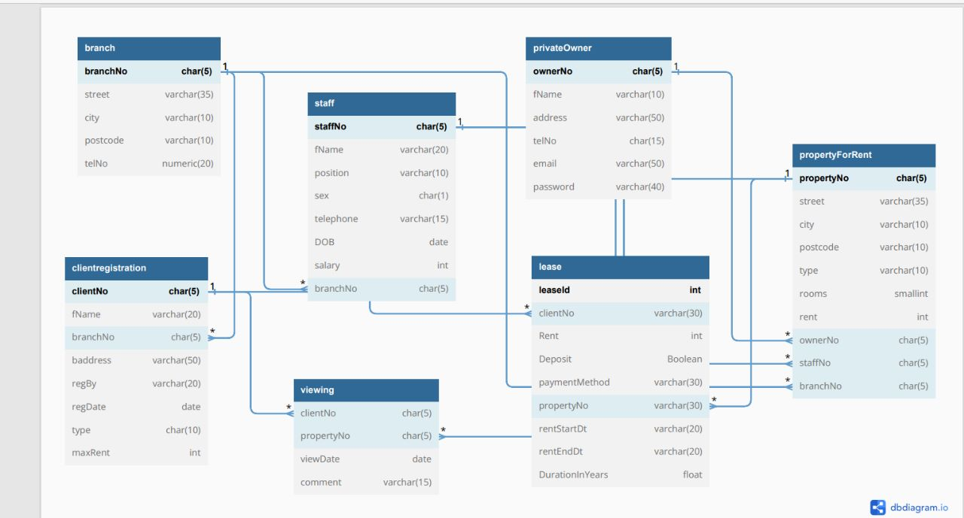

Interface:

Our interface consists of the following pages which are added as per requirements in the project.

Home page:

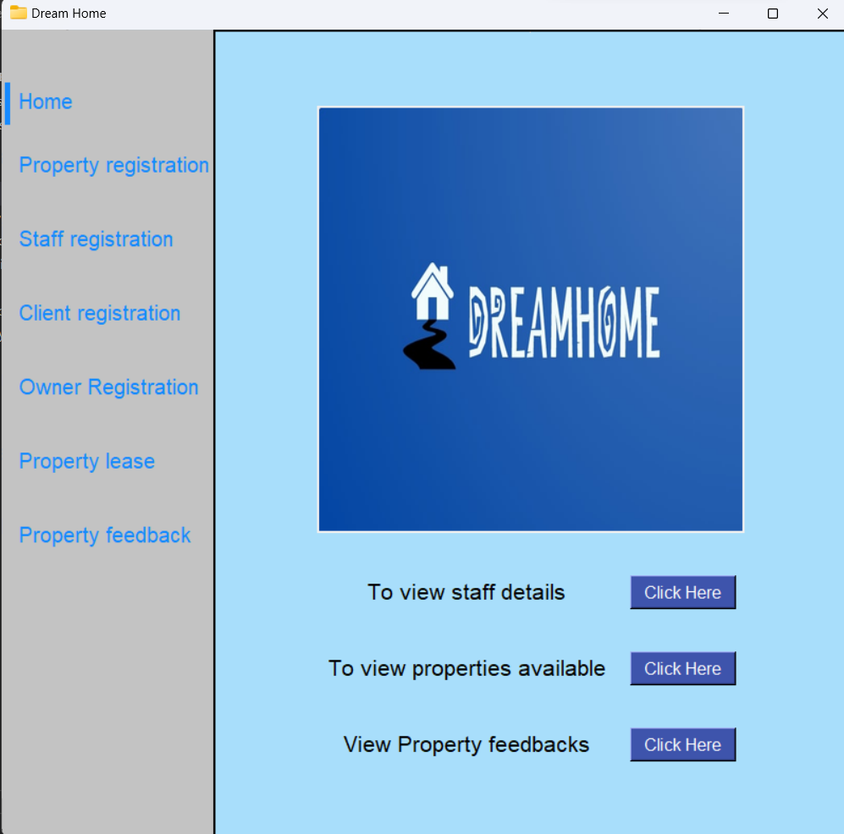

For client registration:

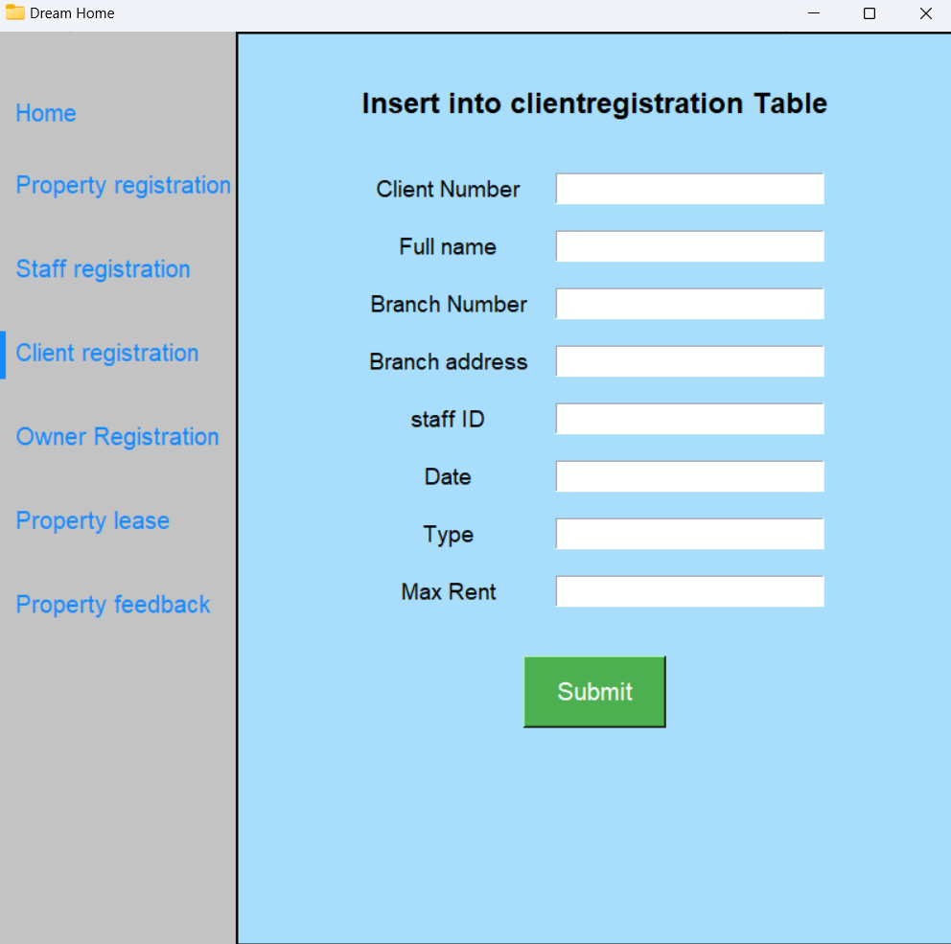

To register property: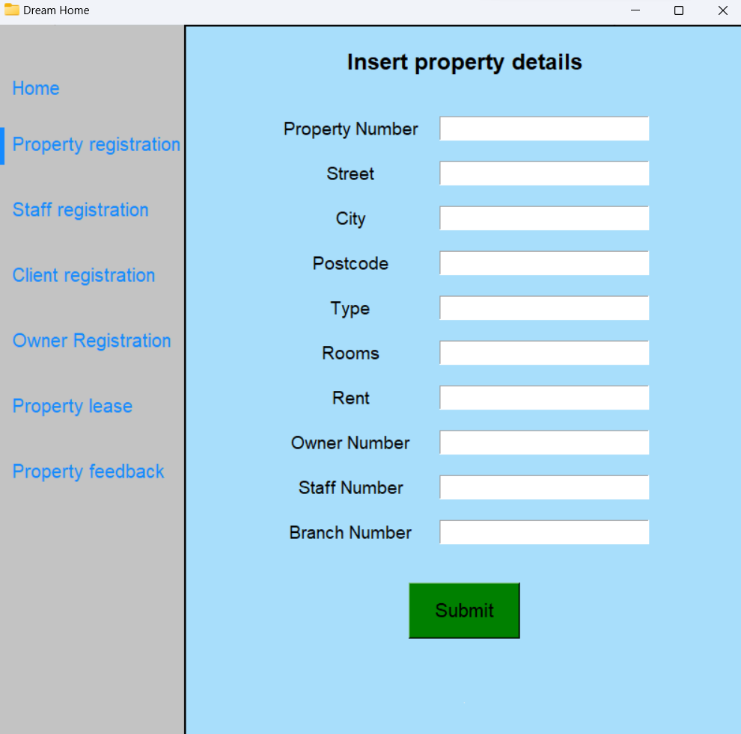

For staff registration: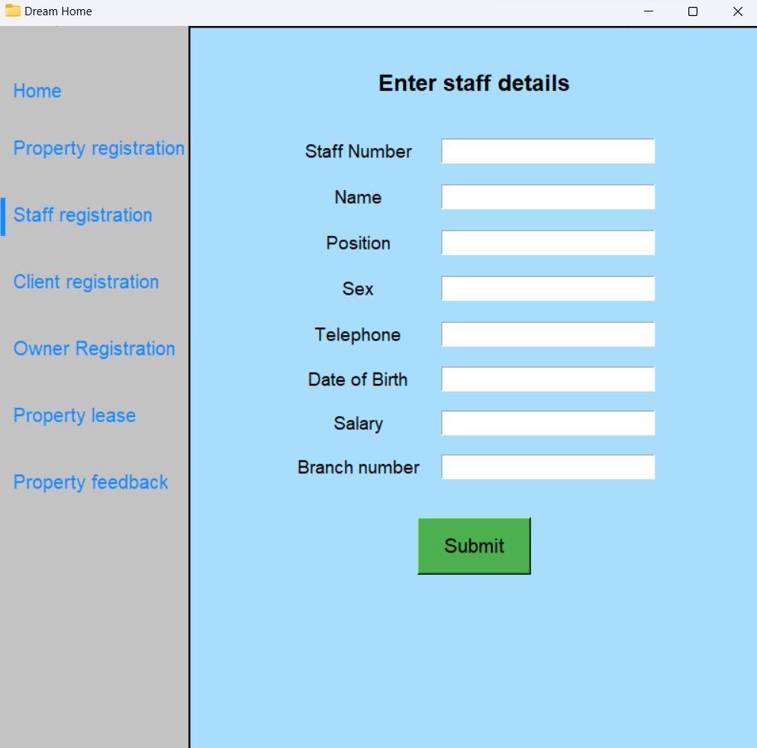

Entry for owner details: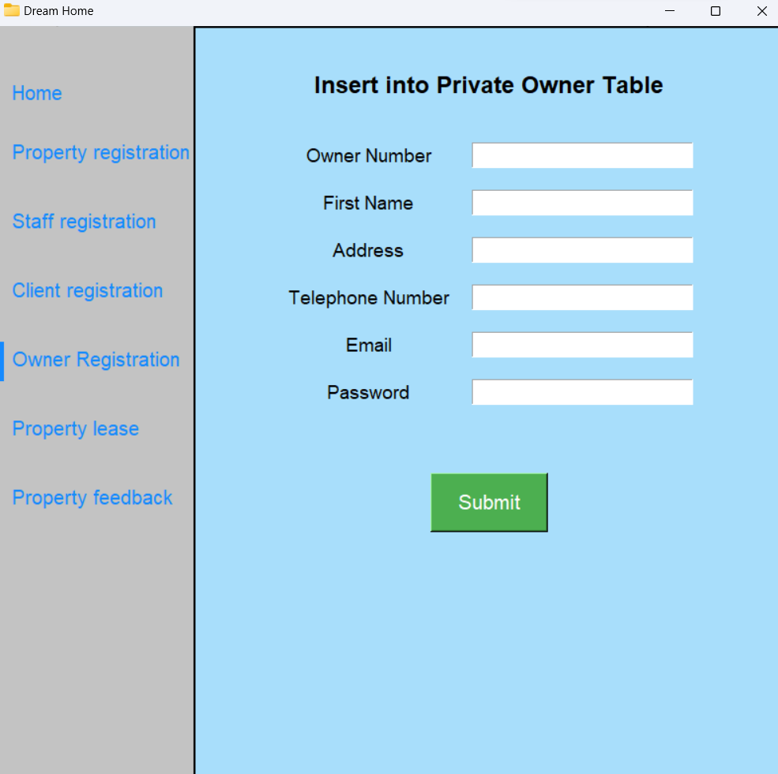

Property leasing details:

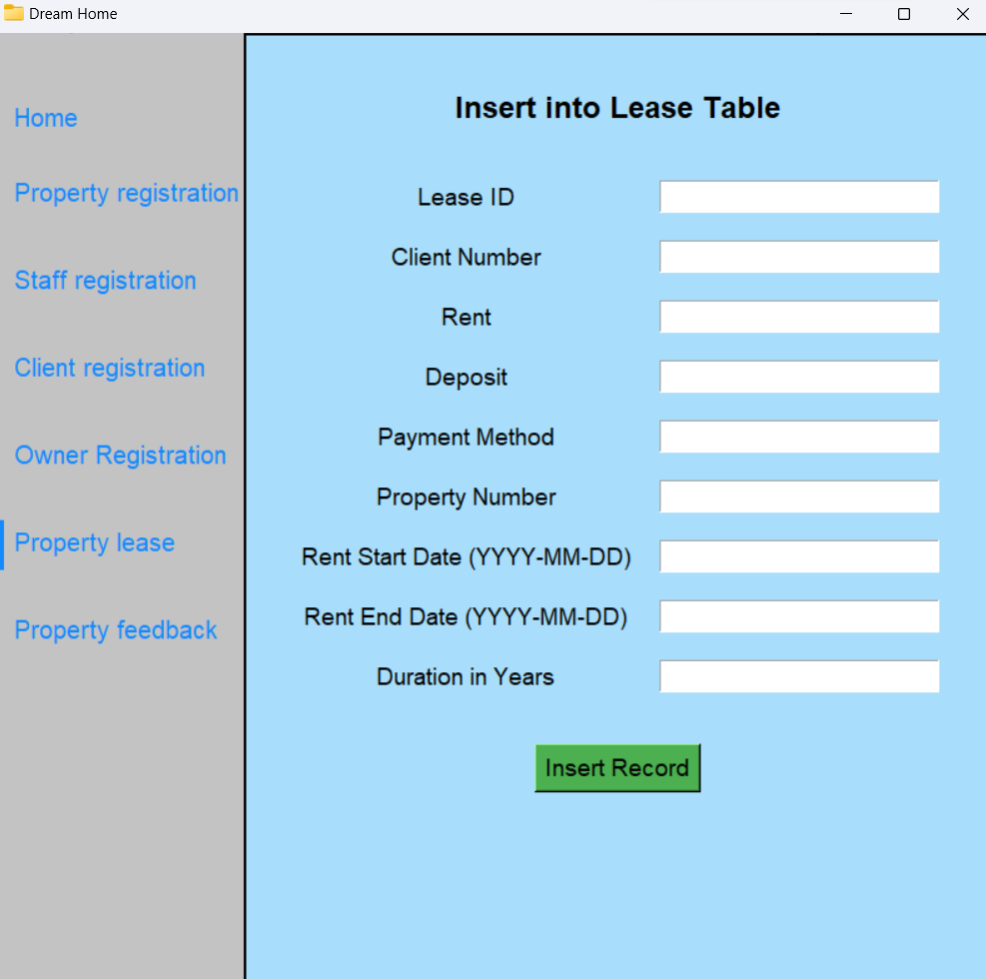

Entry form for feedback: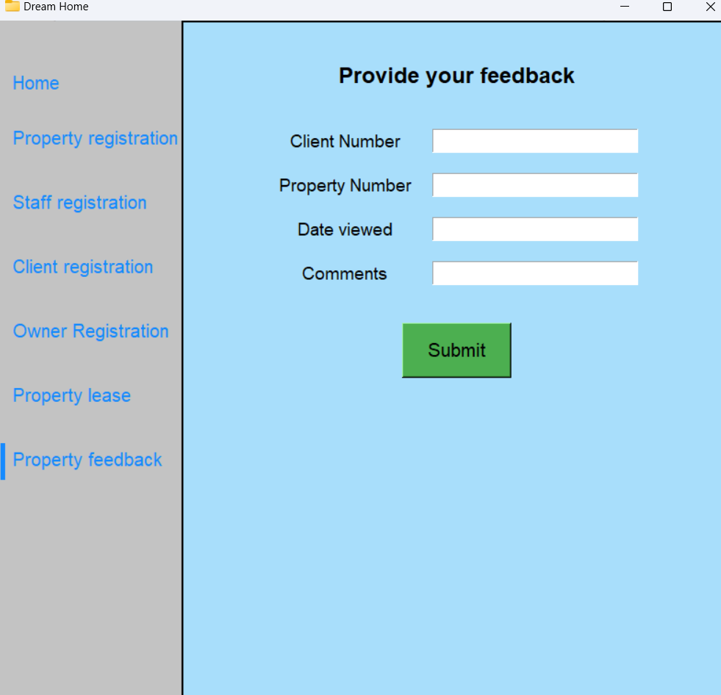

View feedbacks on properties:

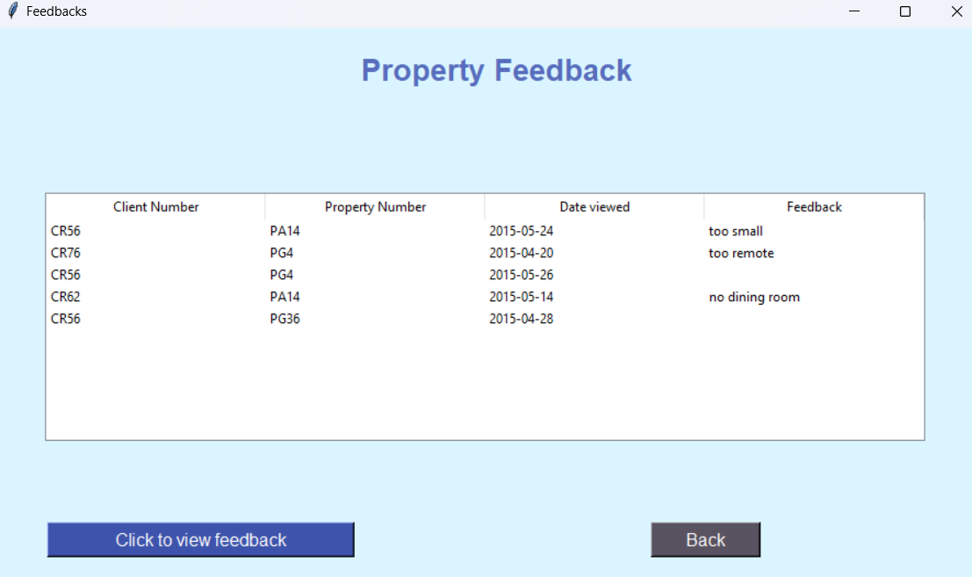

Staff from all branches: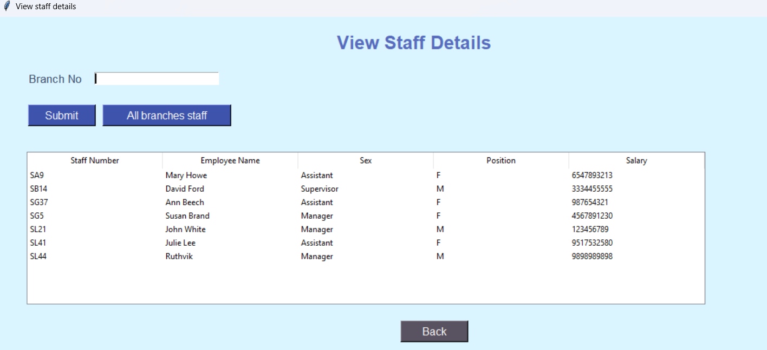

Properties available for rentals:

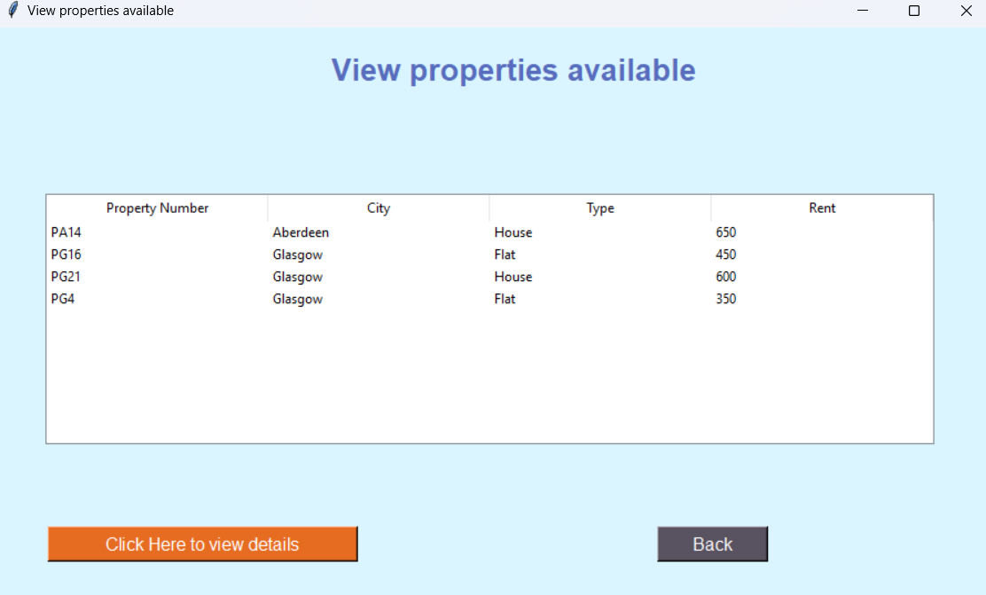

To view staff at specific branch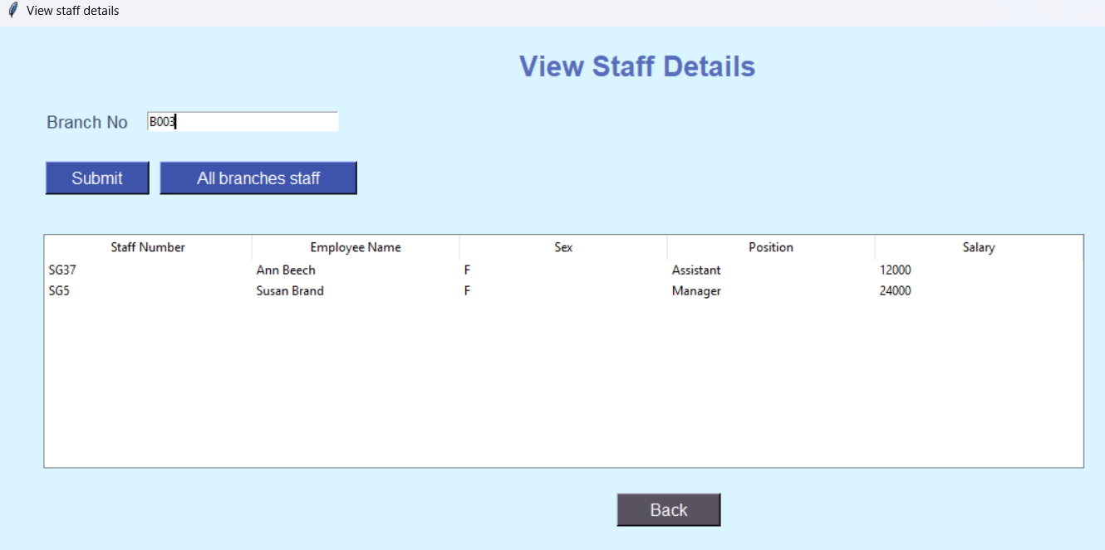

Queries:

Queries required by the Branch:

(a)List the details of branches in a given city.

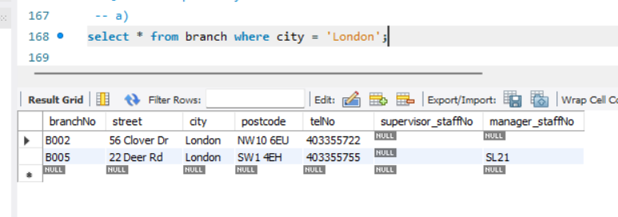

(b) Identify the total number of branches in each city.

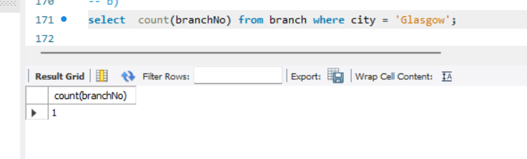

(c) List the name, position, and salary of staff at a given branch, ordered by staff name.

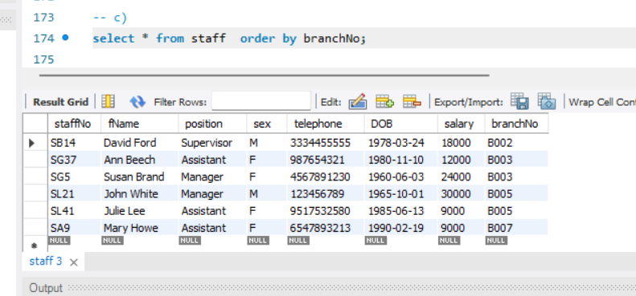

(d) Identify the total number of staff and the sum of their salaries.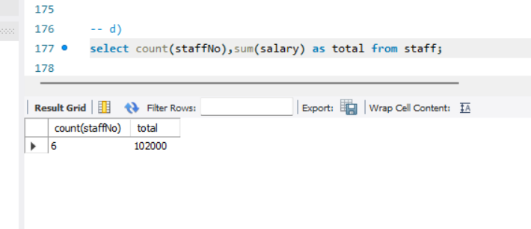

(e) Identify the total number of staff in each position at branches in Glasgow.

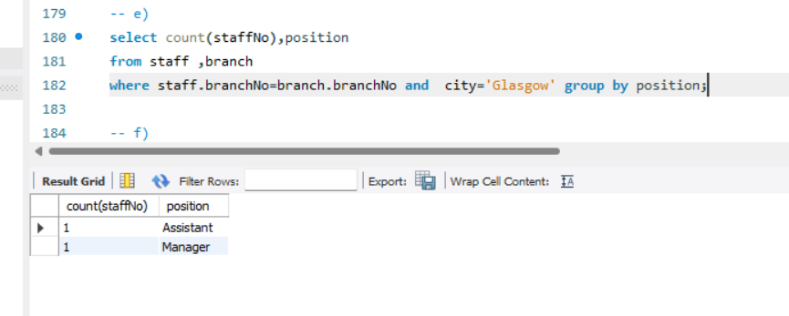

(f) List the name of each Manager at each branch, ordered by branch address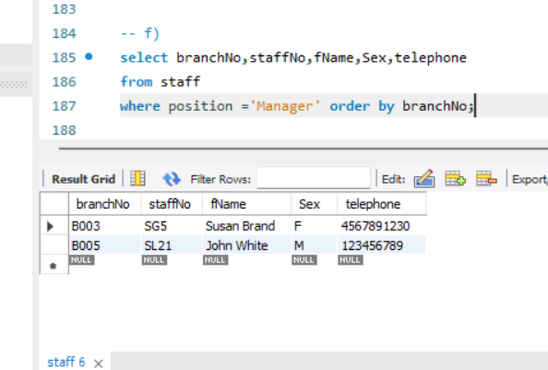

(g) List the names of staff supervised by a named Supervisor.

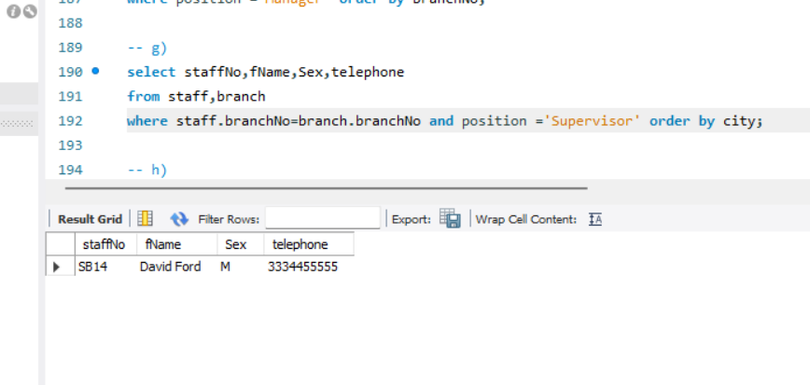

(h) List the property number, address, type, and rent of all properties in Glasgow, ordered by rental amount.

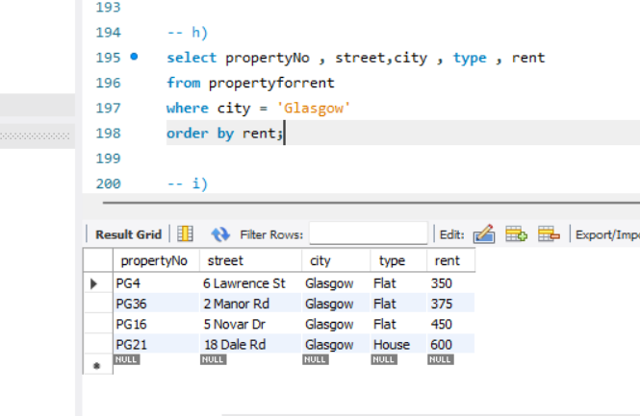

(i) List the details of properties for rent managed by a named member of staff.

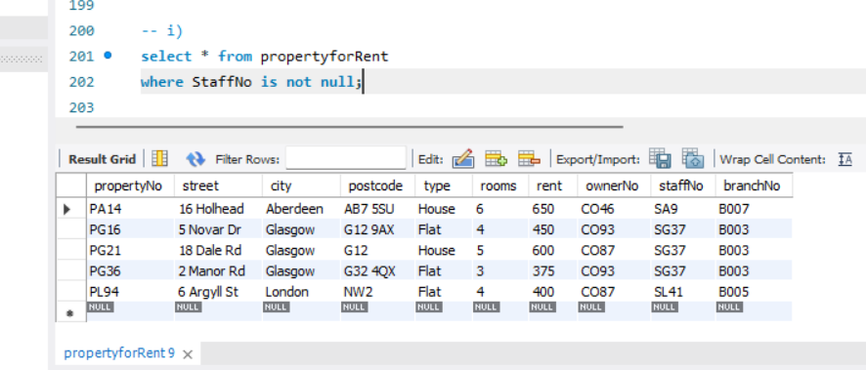

(j) Identify the total number of properties assigned to each member of staff at a given branch.

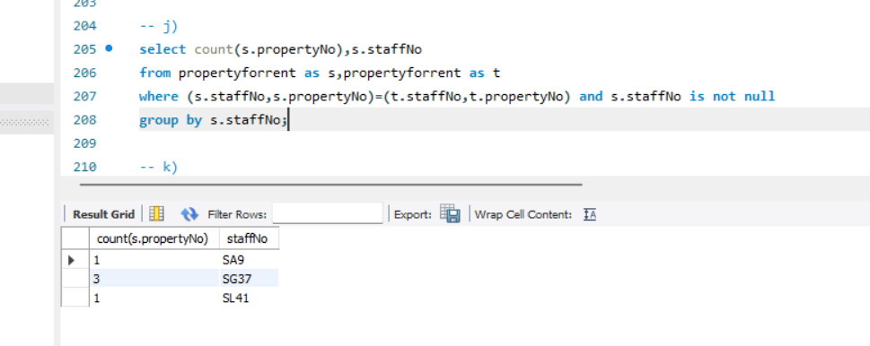

(k) List the details of properties provided by business owners at a given branch.

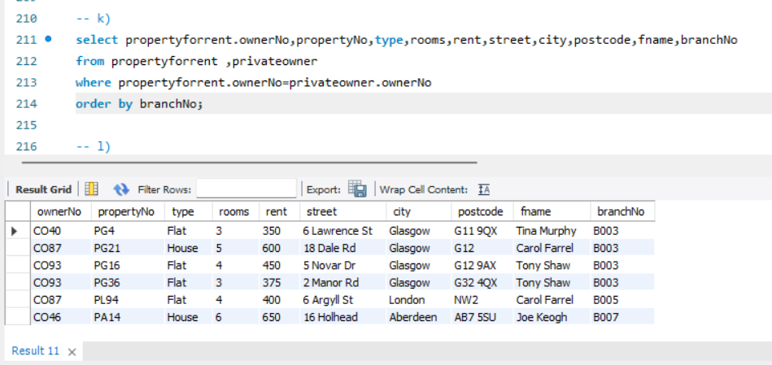

(l) Identify the total number of properties of each type at all branches

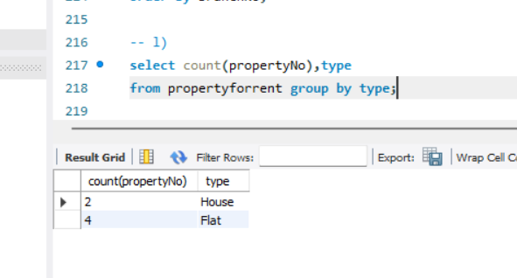

(m) Identify the details of private property owners that provide more than one property for rent.

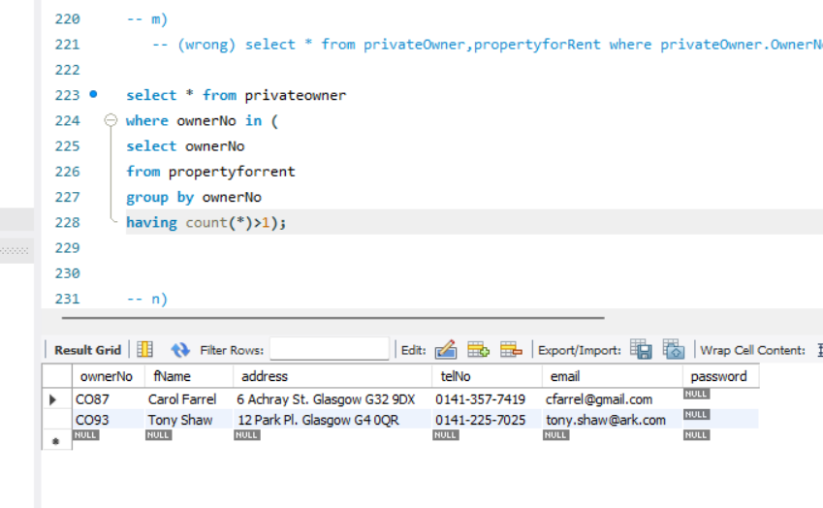

(n) Identify flats with at least three rooms and with a monthly rent no higher than £500 in Aberdeen.

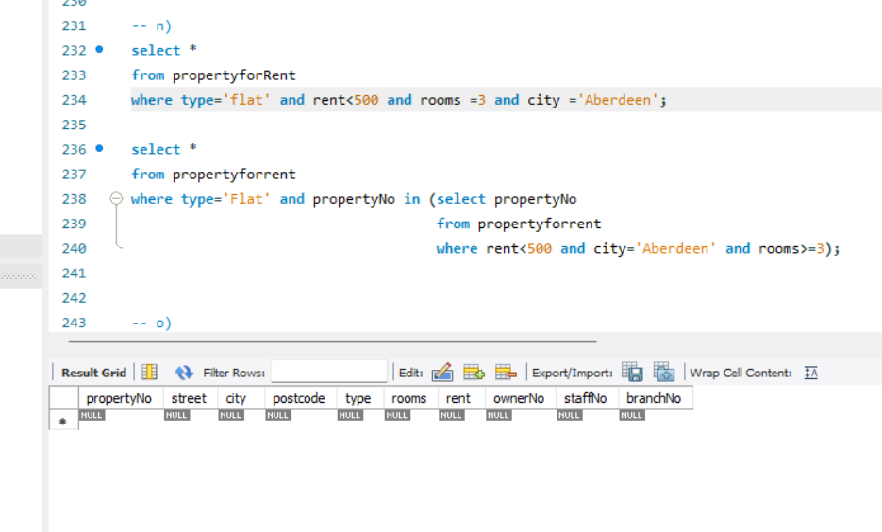

(o) List the number, name, and telephone number of clients and their property preferences at a given branch.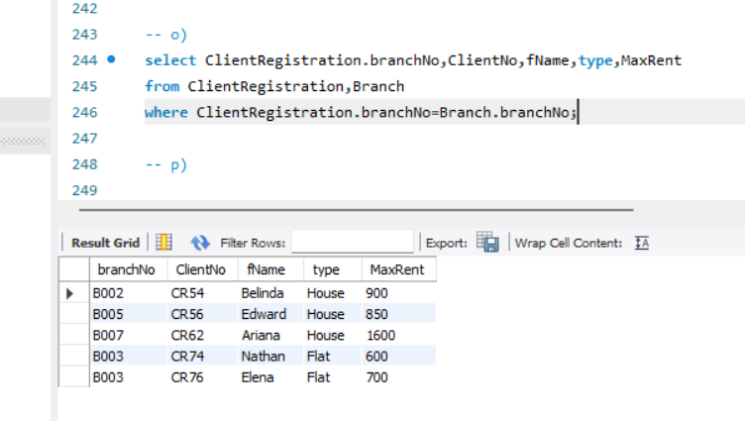

(p) Identify the properties that have been advertised more than the average number of times.

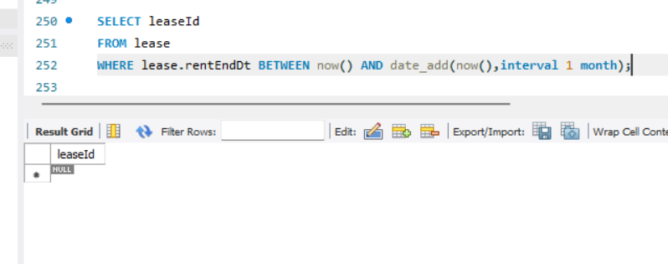

Since we have taken the lease to be of 1 year we don’t have data related to monthly lease

(q) List the details of leases due to expire next month at a given branch.

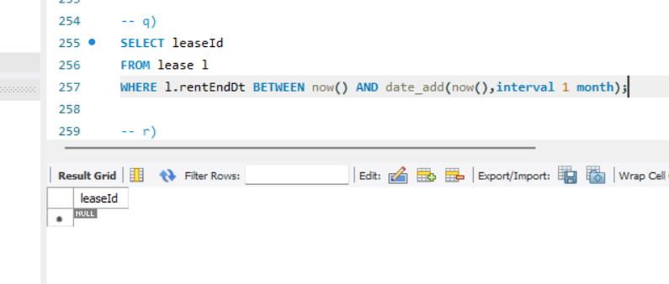

(r) List the total number of leases with rental periods that are less than one year at branches in London.

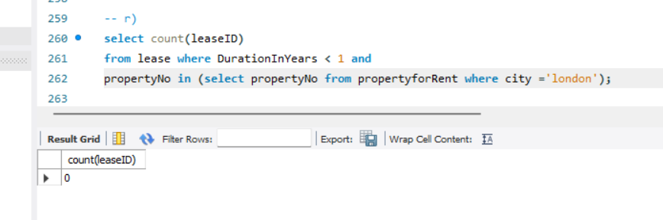

Since rental period is calculated year-wise less than 1 year time data is not present

(s) List the total possible daily rental for property at each branch, ordered by branch number.

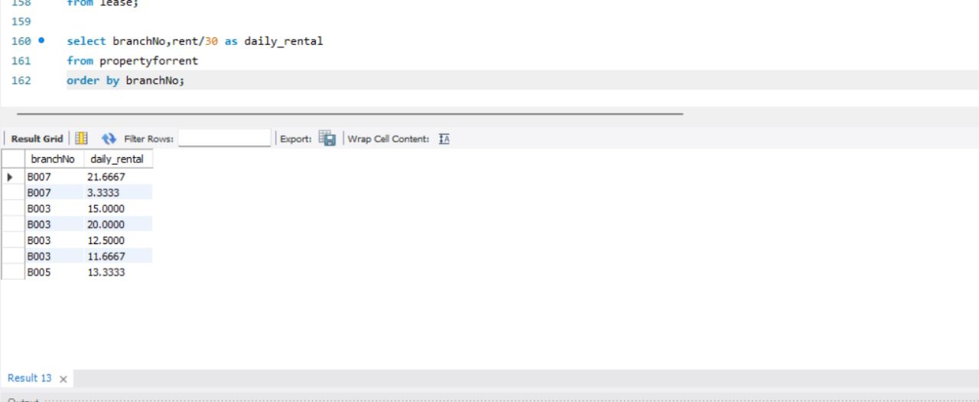

Queries required by the Staff:

(a) List details of staff supervised by a named Supervisor at the branch.

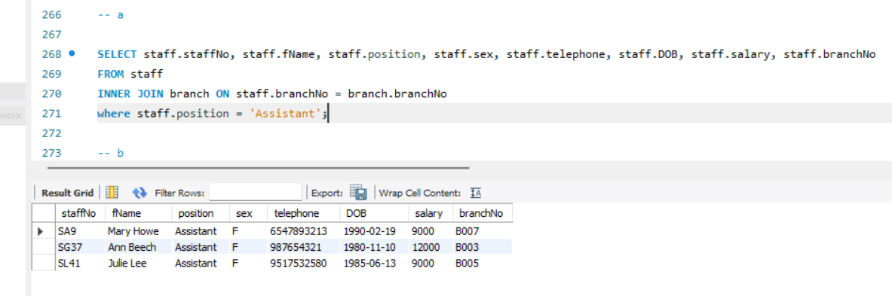

(b) List details of all Assistants alphabetically by name at the branch.

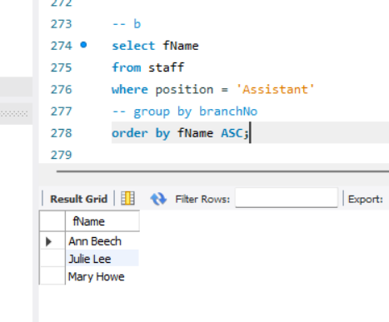

(c) List the details of property (including the rental deposit) available for rent at the branch, along

with the owner’s details.

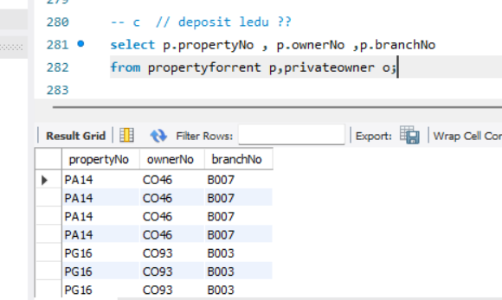

(d) List the details of properties managed by a named member of staff at the branch.

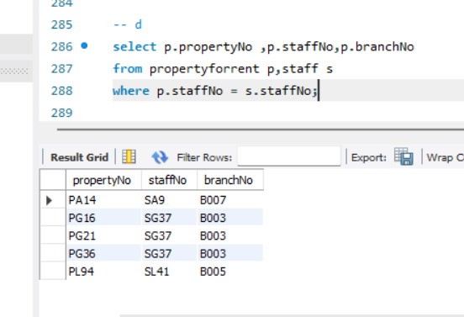

(e) List the clients registering at the branch and the names of the members of staff who registered

the clients.

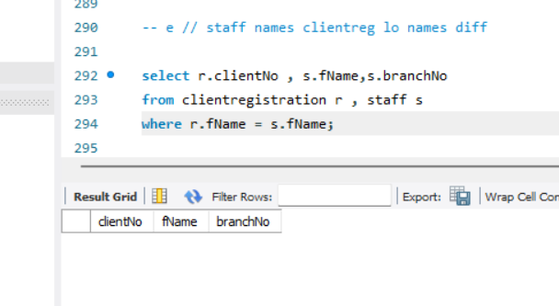

(f) Identify properties located in Glasgow with rents no higher than £450.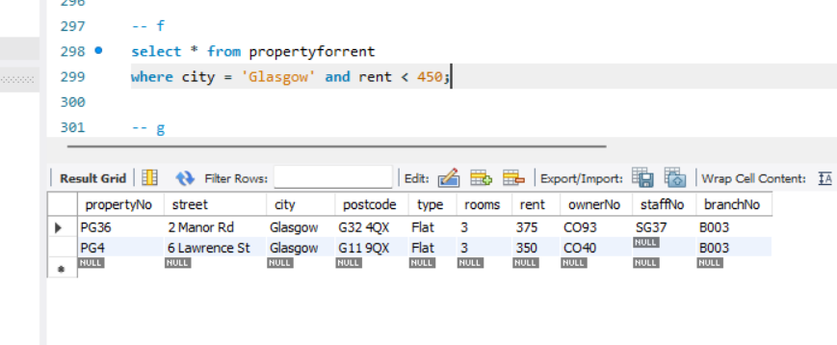

(g) Identify the name and telephone number of an owner of a given property.

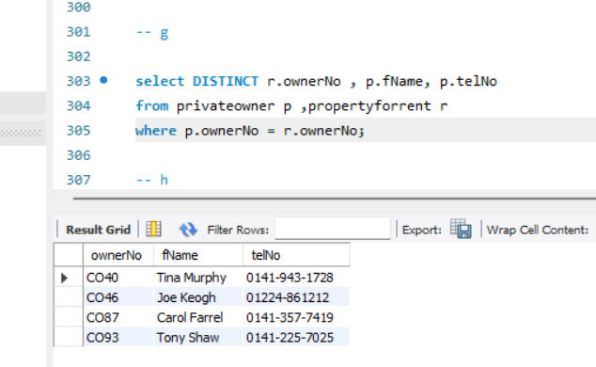

(h) List the details of comments made by clients viewing a given property.

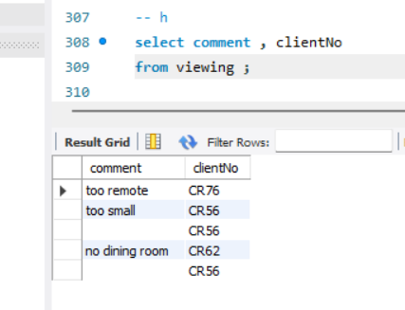

(i) Display the names and phone numbers of clients who have viewed a given property but not

supplied comments.

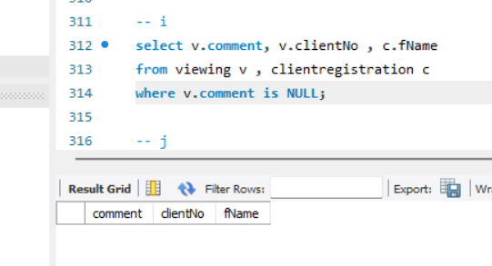

(j) Display the details of a lease between a named client and a given property.

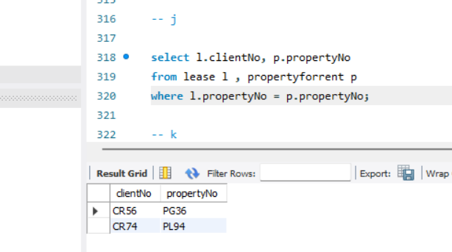

(k) Identify the leases due to expire next month at the branch

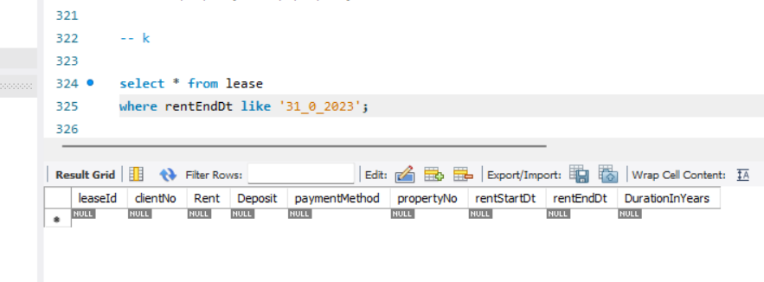

(l) List the details of properties that have not been rented out for more than three months.

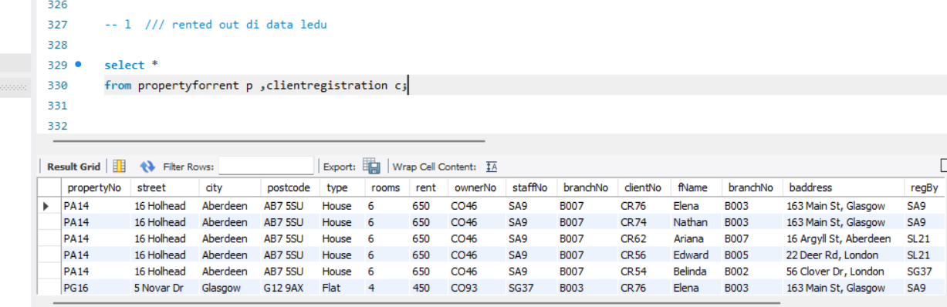

(m) Produce a list of clients whose preferences match a particular property.

